FUNCTIONAL AND PERFORMANCE TESTING

Date | 19/02/2026
Team ID | LTVIP2026TMIDS66407
Project Name | AUTOMATIC CAR CATALOG SYSTEM FOR ENHANCED SHOWROOM MANAGEMENT
Maximum Marks | 4marks

Milestone: Workflow
Purpose:

- Centralizes car inventory data for real-time visibility.
- Automates vehicle listing and update processes.
- Improves customer inquiry handling with quick access to specs.
- Integrates service scheduling and vehicle availability.
- Generates reports for sales and stock performance insights.

Uses:

- Auto-updates inventory–Syncs new car arrivals and availability in real-time.
- Streamlines test drive scheduling –Automates customer booking and reminders from the Customers.
- Simplifies vehicle detail access–Centralizes specs,images,and pricing for sales teams.
- Tracks customer interactions–Logs inquiries and preferences for follow-up.
- Generates performance reports–Provides insights on popular models and sales trends.
Activity : Workflow Assignment to Mahendra service Catalog.

- Navigate to Homepage.
- Click on all search Workflow Editor.
- Click on New Workflow.
- Under the name field search for Test Select that record.
- After creating workflow you can see begin and end.
- Drag the approval user from core and give name as sales.
- Give the user as a salesperson.
- Drag the approval userfrom core and give name as 2nd level.
- Add a user as supervisor.
- Drag create task from core and give name as car company
- Give task type car fulfillment table and priority-1.

- Give task values from values
- Set values as car status Ready to Pickup.
- State Closed Complete and submit.
- Drag the create task from core and give it name as car production.
- Give task type car fulfillment table and priority-1.
- Give task values from values
- Set values as car status deployment failed.
- State closed In complete And Submit.
- Drag Notification from core and give name as Booking Notification.
- Add To user as Abraham Lincoln and group as Showroom.
- Give the subject as car showroom and message

Program:
<html>
<body style="font-family: Arial, sans-serif;">

<!-- Background Logo Wrapper -->
<div style="background-image: url('${C:\Users\saipr\OneDrive\Pictures\Screenshots\Screenshot 2024-10-28 125727.png}'); background-size: contain; background-repeat: no-repeat; background-position: center; padding: 20px; text-align: center;">

<!-- Overlay Content -->
<div style="background: rgba(255, 255, 255, 0.8); padding: 20px; border-radius: 8px;">
<h2 style="color: #333;">Car Request Notification</h2>
<p style="color: #555;">
Hello, your request for a car model has been submitted and approved.
</p>

<!-- Dynamic Fields -->
<p><strong>Requested Car:</strong> ${requested_for}</p>
<p><strong>Status:</strong> ${approval}</p>

<p style="color: #333;">Thank you for choosing Mahendra!</p>
</div>

</div>

</body>

</html>

- Submit.

- Drag the Notification and give the name as car reject
- Add To user as Abraham Lincoln and add group showroom.
- Give the subject as a car showroom.
- Give a message as car booking approval is rejected.
- Submit and end

Output Result:
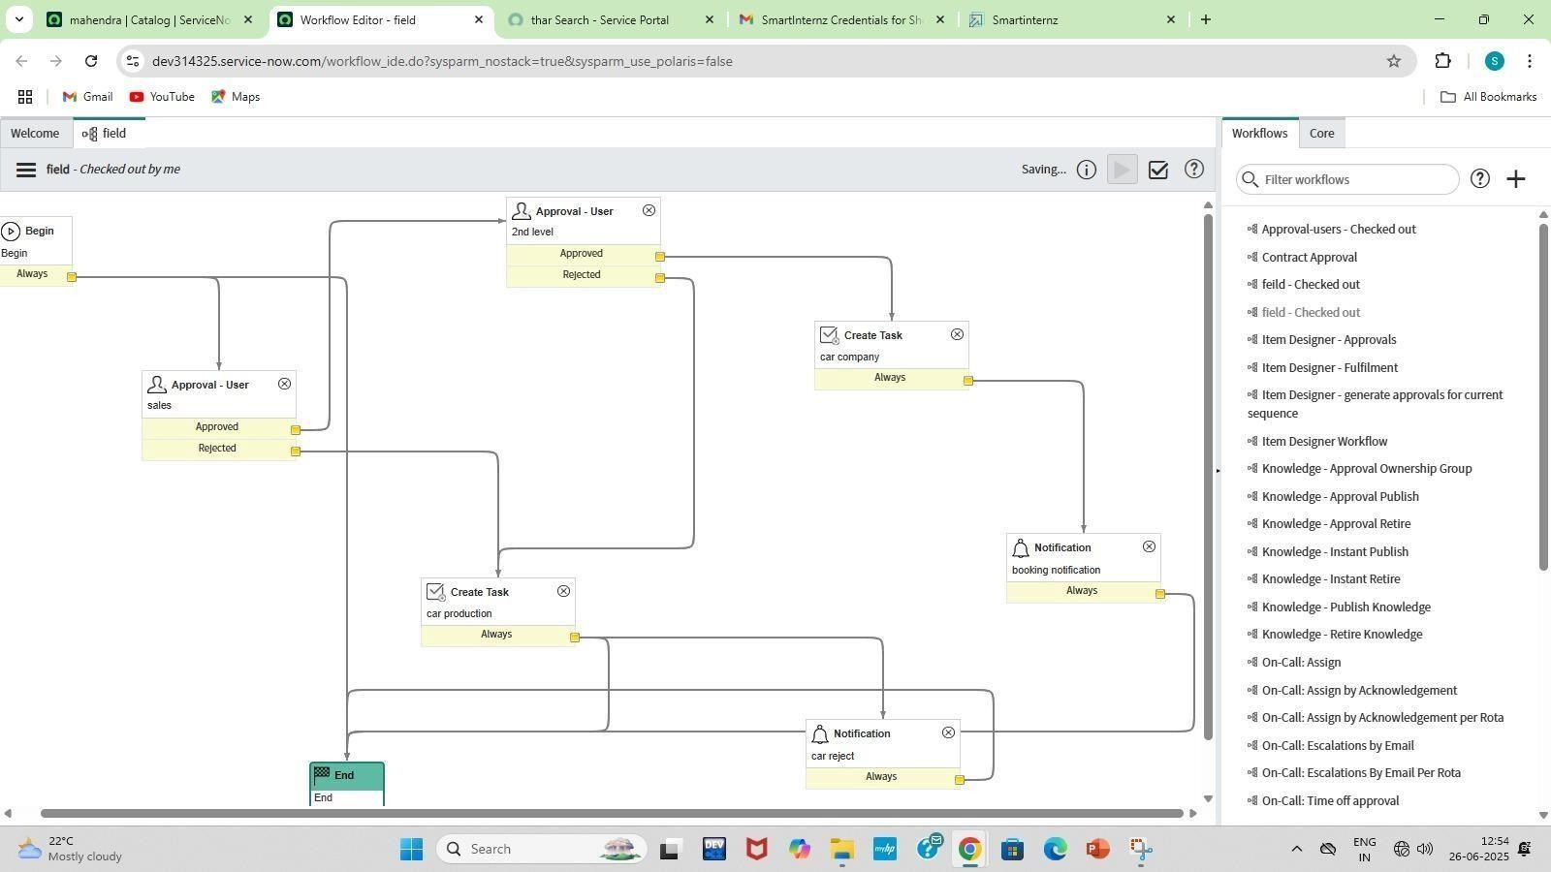

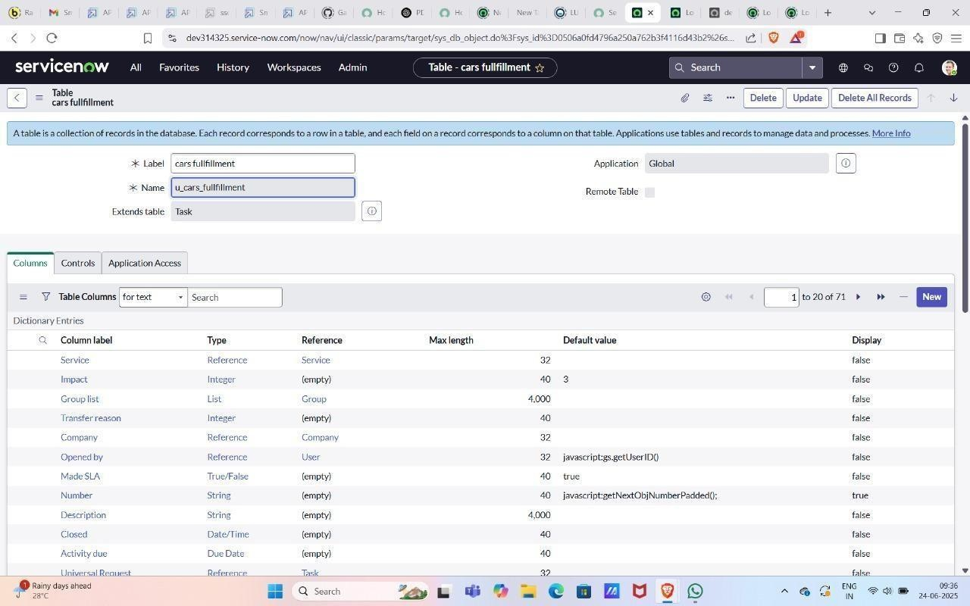

Advantages & Disadvantages :

Advantages of Servicenow :

  - Workflow Automation : Service Now excels at automating a wide range of business processes across IT, HR, customer service, and more.

  - Single System of Record : It provides a unified platform to manage various departmental operations, breaking down silos and offering a holistic view of workflows, data, and services.
  - Scalability and Flexibility : Being a cloud-native platform, ServiceNow can easily scale to meet the needs of growing organizations, from small businesses to large enterprises

  - Enhanced User-Experience(Self-Service) : ServiceNow offers intuitive self-service portals and mobile apps, empowering users to find answers, request services, and track progress independently.

  - Data-Driven Insights and Reporting : With built-in analytics and reporting tools, Service Now provides valuable insights into operations, performance, and trends, enabling data- driven decision-making and continuous improvement.

  - Integration Capabilities : The platform boasts robust integration capabilities (e.g., through Integration Hub) to connect with other existing systems and applications, creating a seamless flow of information across the enterprise.

  - Improved Collaboration : By centralizing information and workflows, Service Now facilitates better communication and collaboration among different teams and departments.

  - Security and Compliance : ServiceNow provides as a secure cloud environment with features like role-based access control, multi-factor authentication, and real-time compliance tracking to protect sensitive data.

Disadvantages of ServiceNow :

  - Cost : ServiceNow is a premium enterprise solution, and its licensing costs can be substantial, especially for smaller or mid-sized organizations. Implementation and ongoing maintenance also contribute to the overall expense.

  - Complexity and LearningCurve : While powerful,ServiceNow can be complex to setup, configure, and manage. It requires specialized skills and dedicated administrators or partners to fully leverage it’s capabilities. The initial learning curve for new users can also be steep.

  - Extensive Customization Challenges : While customization is a strength, over- customization or poorly planned customizations can lead to technical debt.

  - Implementation of Time and Effort : A successful ServiceNow implementation often requires significant time, planning and resources including organizational change management to ensure user adoption.
  - Vendor Lock-in : Due to the deep integration and reliance on the ServiceNow ecosystem, organizations might experience a degree of vendor lock-in,making it difficult to switch to other platforms in the future.

  - Limited NLU/AI Maturity (in some areas) : While ServiceNow incorporates AI, particularly in Virtual Agent, some users find its Natural Language Understanding(NLU) capabilities can be limited for highly.

Conclusion :

The core purpose of ServiceNow is to make work, work better for people and businesses. It achieves this by transforming manual, siloed processes into intelligent, connected digital workflows across the entire enterprise. Primarily, it aims to automate and optimize service delivery, whether in IT, HR, customer service, or other operational functions. By providing a unified cloud platform with a common data model, ServiceNow breaks down departmental barriers, enabling seamless information flow and collaboration. ServiceNow is a cloud-based platform designed to streamline and automate IT service management (ITSM) and enterprise Workflows.
It’s purpose is to enhance efficiency,visibility and user experience across departments like IT, HR, and Customer Service. Looking ahead, the future scope of Service now

